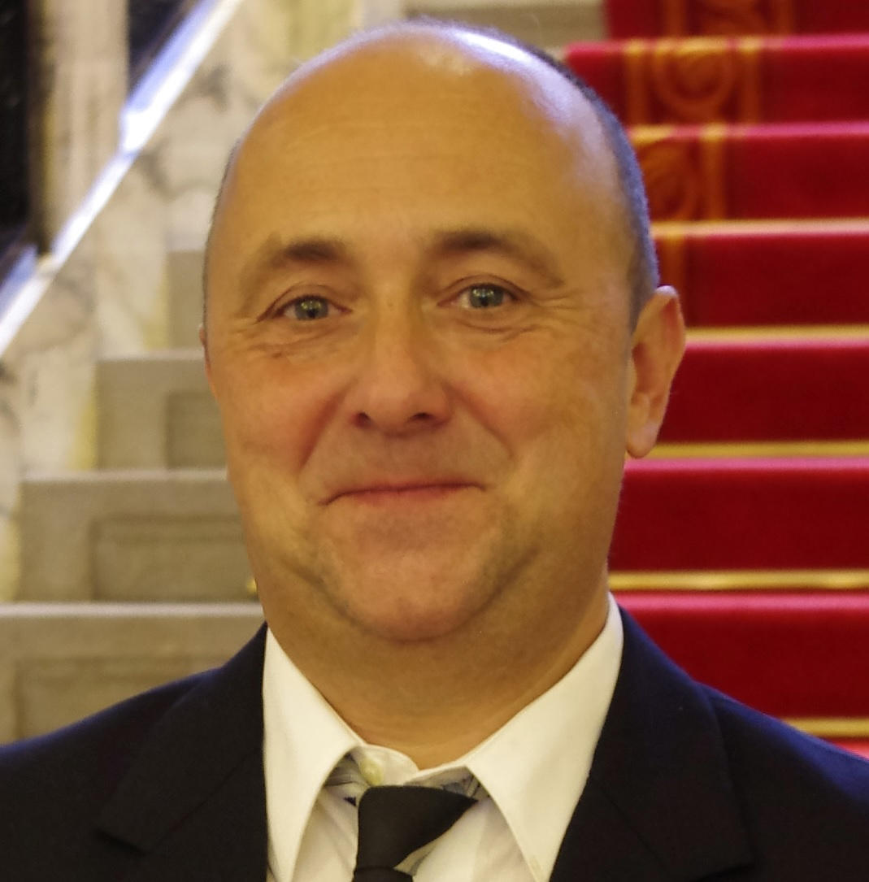 Dr. Ivo Piantanida

PERSONAL: Born September 5, 1967, Zagreb, Croatia.

CURRENT EMPLOYMENT AND DUTIES
- 2017- : Senior Scientist with tenure, Laboratory for Biomolecular Interactions and Spectroscopy (head), Division of Organic Chemistry & Biochemistry, Ruđer Bošković Institute, Zagreb, Croatia
- 2016- : Full professor at the University of Rijeka, School of Medicine, Croatia

- PREVIOUS WORK EXPERIENCE
- 2017 – current: Senior Scientist with permanent tenure, Laboratory for biomolecular interactions and spectroscopy (Head), Division of Organic Chemistry & Biochemistry, Ruđer Bošković Institute, Zagreb, Croatia
- 2011 – 2017: Senior Scientist, Laboratory for biomolecular interactions and spectroscopy (Head),
Division of Organic Chemistry & Biochemistry, Ruđer Bošković Institute, Zagreb, Croatia
- 2007 – 2011: Senior research associate, Ruđer Bošković Institute, Zagreb, Croatia
- 2003-2007: Research Associate, Ruđer Bošković Institute, Zagreb, Croatia
- 2001-2003: Senior research assistant (postdoctoral position), Ruđer Bošković Institute, Zagreb, Croatia
- 1993-2001: Research assistant (PhD position), Ruđer Bošković Institute, Zagreb, Croatia

EDUCATION
- 1997-2001: PhD; Faculty of Science, University of Zagreb, Croatia, supervisor M. Žinić.
- 1993-1997: Master of Science Thesis, Faculty of Science, University of Zagreb, Croatia, supervisor M. Žinić.
- 1987-1993: Diploma Thesis, Faculty of Chemical Technology, University of Zagreb, Croatia.

LANGUAGES: Croatian (mother language), English (excellent), German (good), Italian (good).

FELLOWSHIPS, SCHOLARSHIPS, AND AWARDS
- 2020: The Croatian Academy of Sciences and Arts Award, in recognition of extraordinary scientific achievements in the field of mathematical, physical and chemical sciences
- 2014: The Croatia National Science Award, for scientific accomplishments in the field of chemistry.
- 2002: “Vladimir Prelog” Award of the Croatian Chemical Society and Pliva Ltd pharmaceutical industry for young organic chemists.
MEMBERSHIPS
- 2022: Fellow of the Croatian Academy of Sciences and Arts
- 2002– current Member of the Croatian Chemical Society

TEACHING AND SUPERVISION

Currently supervising 2 PhD students, so far 10 MSc and 6 PhD theses mentored.

2010 – Full Professor, Division of Biotechnology, University of Rijeka and Head of the Module 5 in the Ph.D. study “Medicinal Chemistry”.

2007 – Lecturer at PhD study "Molecular Biosciences" University of Osijek.

REFEREEING
- Reviewer in >40 journals including: Angew. Chem., J. Am. Chem. Soc., Chem. Sci., J. Med. Chem.; Chem, Eur. J.; Eur. J. Med. Chem.; Chem. Commun., J. Org. Chem., etc.

Memberships in journal editorial teams:
- 2019 – current: Editor at MDPI Molecules, Bioorganic Chemistry section https://www.mdpi.com/journal/molecules/sectioneditors/bioorganic_chemistry
- 2020: Editor of thematic issue “Molecular Recognition” Beilstein Journal of Organic Chemistry

RECENT PROJECTS
- 2020 - 23. | WP head in Horizon 2020 FETPROACT-EIC-06-2019, Project: 952110 “MARA-BASED INDUSTRIAL LOW-COST IDENTIFICATION ASSAYS” (MARILIA) | 2 mil. EUR
- 2018 - 23. | Principal investigator of the Croatian Science Foundation Project (grant No. 5475) "Multichromophore probes for recognition of particular DNA, RNA and protein structures" | 994.000 HRK
- 2016-17 | HAMAG-Bicro Proof of Concept (PoC6) PoC6_11_71-U-1 “Novel method for detection of mycotoxin STC in food and environment" | 342.000 HRK
- 2014–18  - 2015–16 | Croatian Science Foundation Grant DNA/RNA-MolSense  ESF Grants, KapMedKem | 988.000 HRK  1.842.445 HRK
- 2013–16: | REGPOT Project Call FP7-REGPOT-2012-2013-1; coordinator Dr. Oliver Vugrek, I. Piantanida Head of WP3 (purchase, installation of new equipment). | 4.880.000 Eur
DISSEMINATION RECORD

8 plenary, >20 invited lectures and oral presentations at conferences, as well as >50 invited lectures at distinguished institutions

PUBLICATION RECORD

175 scientific articles in CC and Wos bases indexed journals (fields chemistry, medicinal chemistry), till now > 3500 times cited (20 citations per paper), >2500 non- self-citing, H factor = 32(Wos) / 32 (Scopus). Corresponding author on >100 scientific articles, >50 articles published in top chemistry journals (IF=5-13), 90 articles in the excellent chemistry journals (IF=3-5, mostly Q1 WosCC base). Two patent applications. Book chapter in RSC Series: Monographs in Supramolecular Chemistry Vol. 13, Supramolecular systems in biomedical fields, 2013. pp. 213.

Full list of papers (175) see https://www.croris.hr/crosbi/searchByContext/2/7443?TIP_RAD=760

Selected publications:
- - M. Ferger, Ž. Ban, I. Krošl, S. Tomić, L. Dietrich, S. Lorenzen, F. Rauch, D. Sieh, A. Friedrich, S. Griesbeck, A. Kenđel, S. Miljanić, I. Piantanida, T. B. Marder Chem. Eur. J. 27 (2021), 5142, doi.org/10.1002/chem.202005141 front cover
- - Ž. Ban, S. Griesbeck, S. Tomić, J. Nitsch, T. Marder, I Piantanida, Chem. Eur. J. 26 (2020) 2195-2203. front cover and „Cover Profile“ DOI: 10.1002/chem.201905568
- - T. Šmidlehner, M. Badovinac, I. Piantanida, New J. Chem. 42, (2018), 6655-6663. Back cover
- - M. Li, M. Radić Stojković, M. Ehlers, E. Zellermann, I. Piantanida, C. Schmuck, Angew. Chem. Int. Ed. 55 (2016) 13015–13018.
- - I. Crnolatac, I. Rogan, B. Majić, S. Tomić, T. Deligeorgiev, G. Horvat, D. Makuc, J. Plavec, G. Pescitelli, I Piantanida Anal. Chim. Acta 940 (2016) 128–135.
- - J. Gershberg, M. Radić Stojković, M. Škugor, S. Tomić, T.H. Rehm, S. Rehm, C.R. Saha-Möller, I. Piantanida, F. Würthner, Chem. Eur. J. 21 (2015) 7886–7895.
- - M. Bončina, Č. Podlipnik, I. Piantanida, J. Eilmes, M.-P. Teulade-Fichou, G. Vesnaver, J. Lah, Nucl. Ac. Res. 43 (2015) 10376-10386.
- - J. Wu, Y. Zou, W. Sicking, I. Piantanida, T. Yi, C. Schmuck, J. Am. Chem. Soc. , 134 (2012), 1958–1961.
- - L.-M. Tumir, I. Crnolatac, T. Deligeorgiev, A. Vasilev, S. Kaloyanova, M. Grabar Branilović, S. Tomić, I. Piantanida, Chemistry, Eur. J., 18 (2012), 3859–3864.
- - T. H. Rehm, M. Radić Stojković, S. Rehm, M. Škugor, I. Piantanida, F. Würthner, Chem. Sci., 3, (2012), 3393–3397.
- - K. Klemm, M. Radić Stojković, G. Horvat, V. Tomišić, I. Piantanida, C. Schmuck; Chemistry, Eur. J., 18 (2012) 1352–1363.
- - L. Hernandez-Folgado, D. Baretić, I. Piantanida, M. Marjanović, M. Kralj, T. Rehm, C. Schmuck; Chemistry, Eur. J., 16 (2010), 3036-3056.
- - M. Hranjec, I. Piantanida, M. Kralj, L. Šuman, K. Pavelić, G. Karminski-Zamola, J. Med. Chem., 51 (2008) 4899–4910. >150 citations
- - M. Hranjec, M. Kralj, I. Piantanida, M. Sedić, L. Šuman, K. Pavelić and G. Karminski-Zamola; J. Med. Chem., 50 (2007) 5696-5711 >200 citations
- - K. Starčević, G. Karminski-Zamola, I. Piantanida, M. Žinić, L. Šuman and M. Kralj; J. Am. Chem. Soc., 127 (2005) 1074-1075
Administrative scientific duties:

Head of the Division of Organic Chemistry and Biochemistry, RBI

2017. – 2021. National Scientific Research Council for Natural Sciences (Vice President for Technology Development and Innovation)

2011 – Member of the Ruđer Bošković Institute Scientific Council

2016. – Head of the Laboratory for Biomolecular Interactions and Spectroscopy

2012-2016. Deputy Head of the Ruđer Bošković Institute Scientific Council;

2012-2016. Head of the Ruđer Bošković Institute Scientific Council for Chemistry;

2002-2004. Secretary of the Croatian Chemical Society;

