REPUBLIC OF CROATIA
RUĐER BOŠKOVIĆ INSTITUTE
Public Scientific Institute of the Republic of Croatia

D E V E L O P M E N T S T R A T E G Y
RUĐER BOŠKOVIĆ INSTITUTE

2026 – 2030

Zagreb, September 2026
Contents
1. Introduction and strategic framework 1
1.1 Legal status 1
1.2 Vision and mission 1
1.3 Mandate 1
1.4 Scope and profile 1
1.5 Relationship to the Program Agreement cycles 2
2. Institutional context and situation analysis 3
2.1 External context 3
2.2 Internal situation 4
2.3 Summary assessment 9
3. Strategic goals and objectives 10
3.1 SC-1 — Advancing scientific excellence 11
3.2 SC-2 — Strengthening cooperation with the economy 11
3.3 SC-3 — Education and talent development 12
3.4 SC-4 — Strengthening social responsibility 13
4. Implementation, monitoring and review 13
4.1 The Program Agreement as the principal instrument of delivery 13
4.2 Funding and the delivery framework 14
4.3 Governance, monitoring and review 14
4.4 The 2028 Program Agreement 15
4.5 Education and talent development outside the contractual framework 15
5. Entry into force 16
Annex 1 — List of abbreviations 17
Annex 2 — Crosswalk: strategic goals to contractual objectives and activities 18
Annex 3 — Mid-point delivery against the Program Agreement indicators 20
SC-1 — Advancing scientific excellence 20
SC-2 — Strengthening cooperation with the economy 21
SC-4 — Strengthening social responsibility 22

Pursuant to Article 29, paragraph 2 of the Statute of the Ruđer Bošković Institute of 22 January 2024, as amended by the Statute on Amendments and Supplements to the Statute of the Ruđer Bošković Institute of 30 March 2026, upon the proposal of the Director and the Scientific Council, the Management Board of the Ruđer Bošković Institute, at its 50th meeting held on September 25, 2026, adopted the
Development Strategy of the Ruđer Bošković Institute 2026 – 2030

1. Introduction and strategic framework

1.1 Legal status
The Ruđer Bošković Institute is a public scientific institute established under Croatian law. The founding rights over the Institute are held by the Republic of Croatia and exercised through the Ministry of Science, Education and Youth (the Ministry). The Institute's legal status, governance structure, and core activities are defined by the Act on Higher Education and Scientific Activity (Official Gazette, No. 119/22) and by the Statute of the Ruđer Bošković Institute.

1.2 Vision and mission
The Ruđer Bošković Institute (Institute or RBI) is Croatia's largest multidisciplinary scientific research Institute, with over 1000 employees.

Vision
The Institute's vision is to be a recognized outstanding European centre of scientific excellence.

Mission
The Mission of the Institute is to advance knowledge-based society through world-class scientific research in the natural, biomedical, biotechnical, and technical sciences, through meaningful contribution to higher education, and through collaboration with industry and the broader public grounded in scientific expertise and integrity.

1.3 Mandate
As a public scientific institute, the RBI's primary mandate is to conduct scientific research in the public interest. This mandate is operationalised through a Program Agreement concluded with the Ministry, which sets out the Institute's strategic goals, specific objectives, activities, measurable indicators, and the allocation of public funding across a four-year period. The current Program Agreement covers the period 2024–2027. The present Development Strategy 2026–2030 provides the Institute's own long-term institutional framework, within which successive Program Agreements are embedded and to which they contribute.

1.4 Scope and profile
The Institute conducts fundamental and applied research ranging from the natural and life sciences through the biotechnical and technical disciplines, organised within eleven scientific divisions (including the Centre for Marine Research) and supported by four scientific support centres (including the Centre for Scientific Information).
The Institute operates from three locations. The Institute's main campus in Zagreb houses the majority +
of its divisions, laboratories, and administrative services. The Centre for Marine Research in Rovinj and the marine and environmental research station on the Martinska peninsula near Šibenik give the Institute a presence on the Adriatic and extend its reach into marine and coastal science.
The Institute's organisational structure is shown in the figure below.
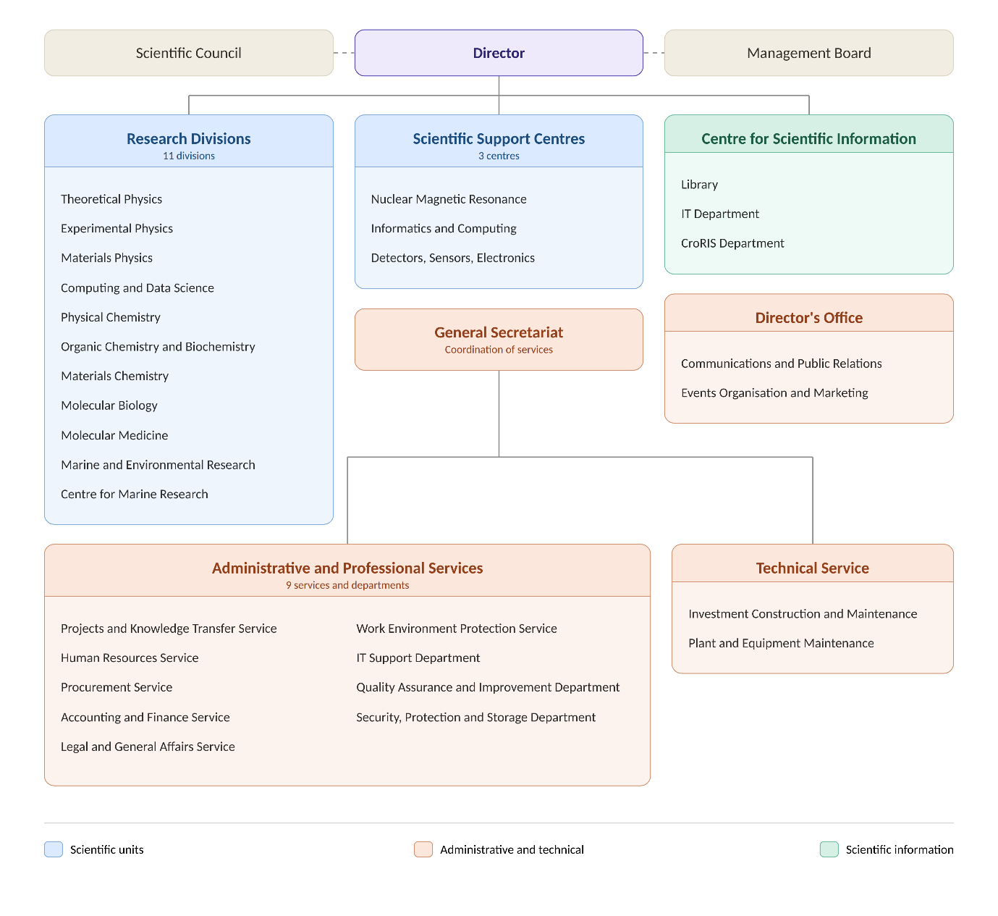
Figure 1. Organisational structure of the Ruđer Bošković Institute.

1.5 Relationship to the Program Agreement cycles
The Development Strategy 2026–2030 is the RBI's own long-term institutional roadmap. As such, it is not derived from or subordinate to any single Program Agreement, but rather provides the strategic framework within which successive Program Agreements are negotiated and implemented.
The Strategy spans a period that bridges two Program Agreement cycles. The current Program Agreement (2024–2027) is past its midpoint as this Strategy comes into effect. The commitments, targets, and activities established under that agreement are fully reflected in the Strategy and inform its baseline position. A new Program Agreement covering the period 2028–2031 will be negotiated with the Ministry during the course of this Strategy. That negotiation will draw directly on the Institute's progress against the goals and indicators set out here, and the new agreement will in turn become the principal instrument for operationalising the second half of the Strategy.
This relationship between the Strategy and the Program Agreement cycles is illustrated in the figure below.
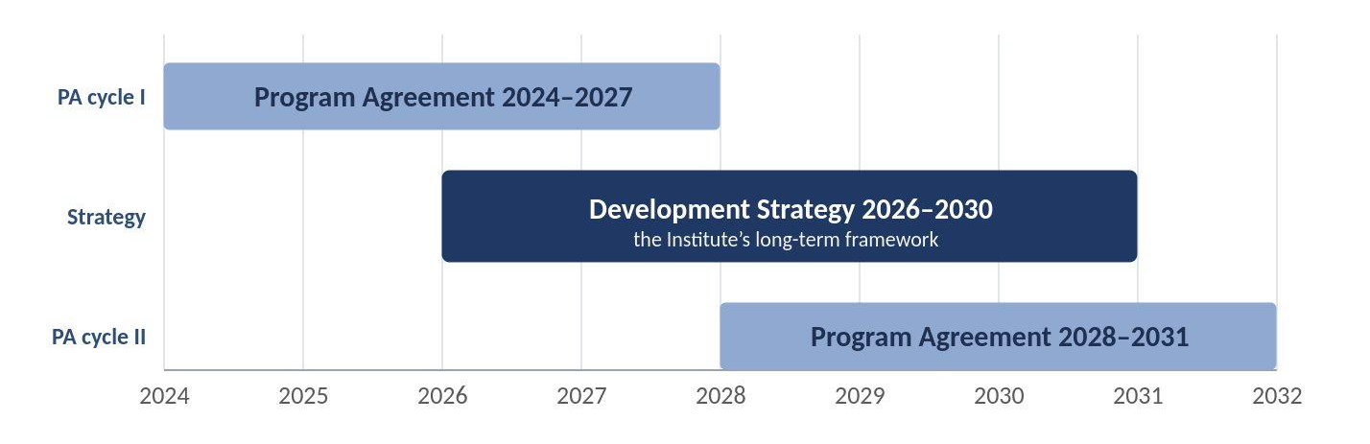
Figure 2. The Development Strategy 2026–2030 in relation to the Program Agreement cycles.

2. Institutional context and situation analysis

2.1 External context
The RBI operates within a national research and innovation system that has expanded in capacity over the past decade while remaining constrained by comparatively low overall investment. Croatia’s gross expenditure on research and development remains below the European Union average as a share of GDP, and the public research base continues to depend heavily on national budget funding supplemented by European sources. This investment gap relative to the EU average represents a persistent structural challenge for the national research and innovation system as a whole, including the RBI. Within this system, the RBI occupies a distinctive position as the country’s largest scientific institute and a principal contributor to its internationally visible research output. National science and innovation policy, articulated through the National Development Strategy 2030 and the Smart Specialisation Strategy of the Republic of Croatia for the period 2023–2030, has increasingly emphasised research excellence, stronger links between science and the economy, and alignment with European priorities; objectives to which the Institute is well placed to respond, but which also raise expectations of the public research sector as a whole.
The Institute's research environment is shaped to a growing degree by the European framework for research and innovation. As a member of the European Research Area, Croatia and its research institutions participate in the Union's collaborative research programmes, principally Horizon Europe, alongside the European structural and investment funds (ESIF) that have supported substantial development of national research capacity. The current period is one of transition. The present cycle of European instruments is approaching its conclusion during the early years of this Strategy. Horizon Europe and the multiannual financial framework (MFF) within which it sits both run to 2027, while the National Recovery and Resilience Plan (NRRP) runs to 2026 and is not expected to be renewed in its present form.
The next cycle is taking shape in parallel. A new multiannual financial framework for 2028–2034 is under negotiation, with the current European Commission proposal envisaging a continued and substantial commitment to collaborative research through Horizon Europe within a broader European Competitiveness Fund. These proposals remain subject to legislative negotiation, and their final scope and structure will become clear over the course of this Strategy. For the RBI, the significance lies less in the precise figures than in the continuity of the framework itself: the Institute's strategic planning must remain aligned with European priorities across a transition between funding cycles, while recognising that the exceptional, one-off capacity support of the recovery instruments will not recur on the same scale.
The structure of research funding has shifted over the past decade toward competitive and project-based mechanisms, and this trend is expected to continue. Institutional or baseline funding, provided through the Program Agreement, remains essential to the stability of the Institute and the maintenance of its research infrastructure and core capabilities. Increasingly, however, the resources available for new research activity, equipment, and the recruitment and retention of researchers depend on success in competitive calls at national and European level.
For an institute of the RBI’s scale and breadth, this environment presents both opportunity and exposure. The Institute’s size, multidisciplinarity, and established track record position it well to compete for and lead substantial projects. At the same time, a growing reliance on competitive funding introduces a degree of volatility into financial planning and places a premium on the Institute’s capacity to prepare, win, and administer complex projects. Maintaining an appropriate balance between stable institutional funding and competitively acquired resources is therefore a central concern for the period of this Strategy. In addition, the growing sophistication and cost of available research methodologies bring rising financial demands, both in procurement and in maintenance, adding further cost pressure on competitively funded research. The Institute must also take account of the newer system of national competitive projects, whose duration has been shortened from four years to three, which requires more frequent proposal preparation and submission and constrains longer-term research in favour of smaller, incremental undertakings, placing additional strain on both research and administrative staff.
Beyond the funding landscape, several broader currents shape the expectations placed on research institutions and inform the priorities of this Strategy. The transition toward open science (encompassing open access to publications, research data management, and reproducibility) has moved from aspiration to expectation, increasingly embedded in the requirements of funders and in the criteria by which research is assessed. Related to this is the ongoing reform of research assessment, which, alongside conventional measures of output, increasingly emphasises the quality, integrity, and societal contribution of research. At the national level, however, the criteria for appointment and promotion to scientific posts, renewed in 2026, continue to rest substantially on quantitative and bibliometric measures, so the Institute must navigate between an international reform agenda and a domestic framework in which conventional indicators of output retain a central role. Expectations that publicly funded research demonstrate tangible societal and economic impact have grown correspondingly, as has the importance of attracting, developing, and retaining research talent in a competitive and internationally mobile environment. Alongside these runs a further shift in the environment for science itself: public trust in expertise and evidence can no longer be assumed, and research institutions increasingly operate amid a contested information landscape in which scientific findings compete with misinformation for public attention. This places a growing premium on the credible public communication of science.
Cutting across these is the accelerating influence of digital technologies, and of artificial intelligence in particular. Artificial intelligence is reshaping research methods across the natural, biomedical, and technical sciences, and is at the same time an object of research and a matter of growing societal consequence in its own right. The pace and ultimate direction of this change remain difficult to predict. The Institute’s position is therefore to engage with it deliberately and adaptively, rather than to fix in advance commitments that the present moment cannot reliably support. Beyond their direct effect on research methods, digital technologies are also driving improvements in the Institute’s business processes, including administrative functions, independent of their application in research itself. In practice this means building the methodological and digital capability of its researchers, contributing to the responsible development and application of these technologies, and remaining able to respond.

2.2 Internal situation
The RBI enters this Strategy period from a position of established scientific strength. Across the current Program Agreement, the Institute met or exceeded every one of its mid-point performance milestones; its position against each contracted indicator is set out in Annex 3. The Institute maintained a high and stable volume of scientific output while improving its quality profile: the share of publications appearing in the most highly ranked journals has risen even as total output has held broadly steady. On international bibliometric measures the Institute is competitive within its regional peer group and highly placed among comparable research organisations worldwide — it ranks 28th (NI-SC₂₀₂₅ ≈ 18) of more than 3,250 non-profit research organisations in the Nature Index Share Count (NI-SC) — while remaining realistic about the distance between an institute of its size and relevant global research centres (e.g. The Francis Crick Institute: 10th, NI-SC₂₀₂₅ ≈ 60).
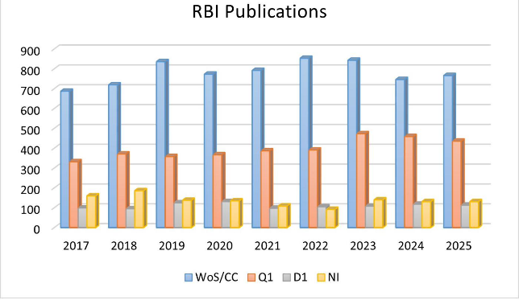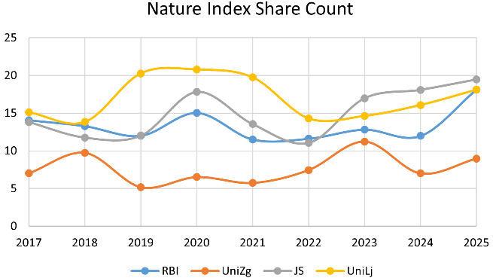

Figure 3. Left: RBI scientific output, 2017–2025. WoS/CC: Web of Science Core Collection; Q1: journals in the top 25% by rank; D1: top 10%; NI: Nature Index. Right: Nature Index Share Count for RBI, the University of Zagreb (UniZg), the Jožef Štefan Institute (JS) and the University of Ljubljana (UniLj).
This performance rests on genuine and distinctive capabilities. The Institute's multidisciplinary breadth allows it to address research questions that cross conventional boundaries, and it has demonstrated a sustained capacity to win and lead major competitive projects, including prestigious individual grants and large collaborative initiatives at the European level. These successes reflect both the quality of the Institute's researchers and an accumulated institutional competence in securing and delivering complex international funding, a capability that has become increasingly central to the Institute's standing and that the Strategy seeks to consolidate.
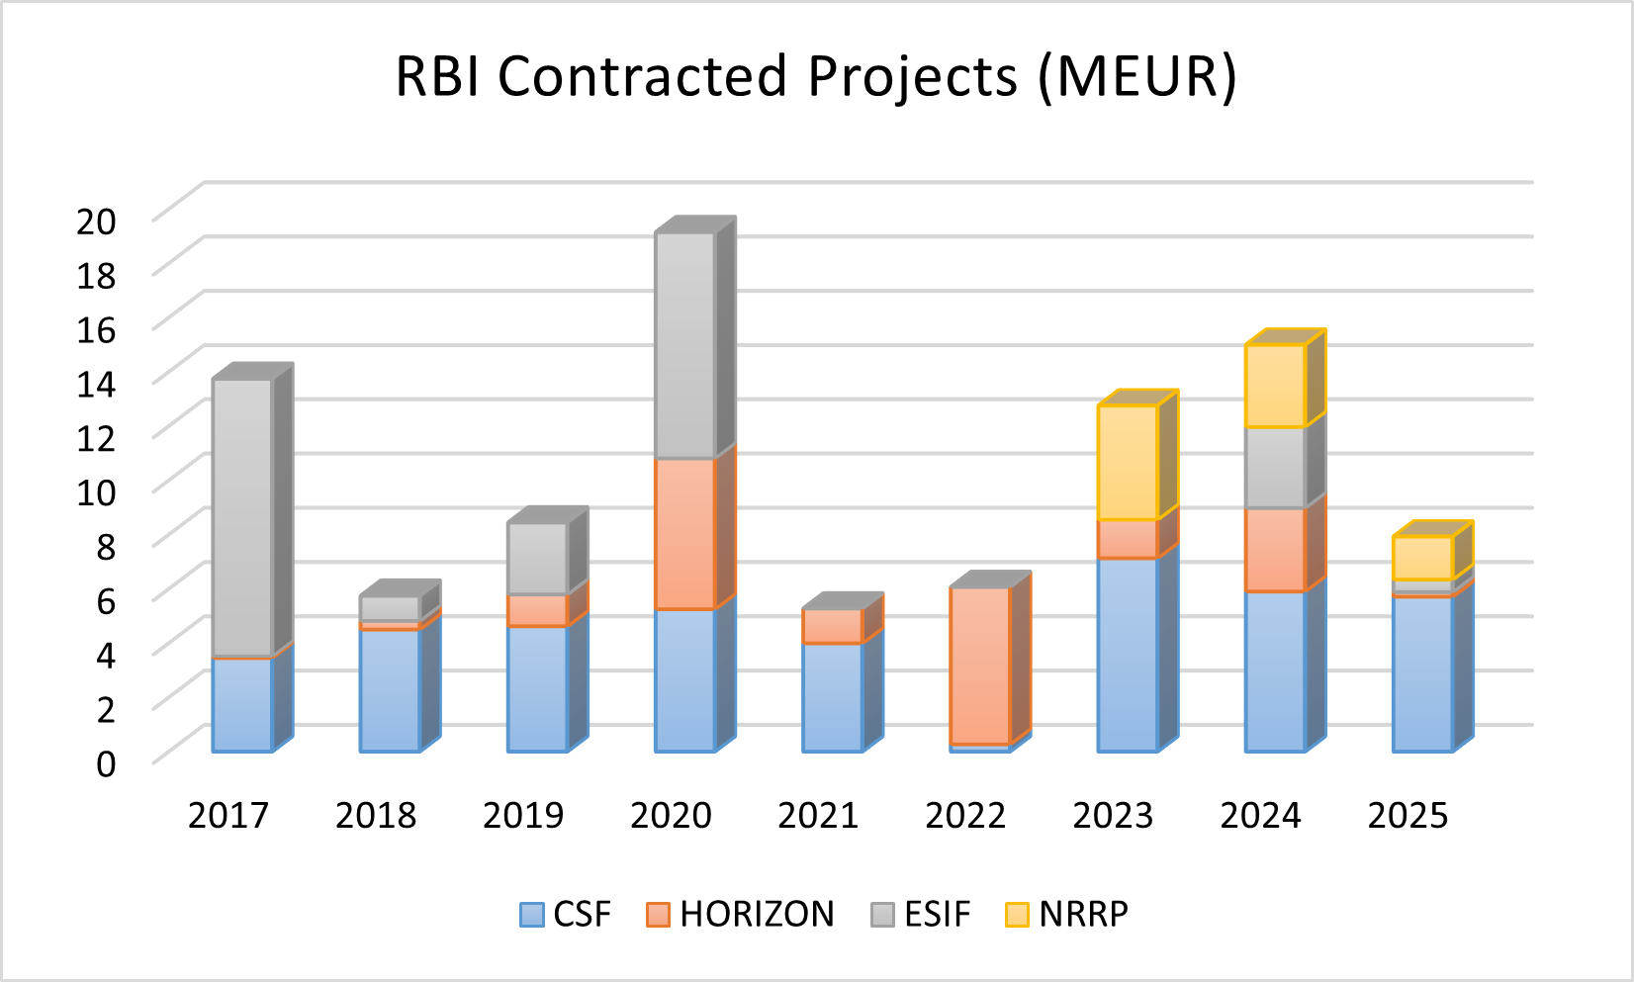
Figure 4. RBI contracted competitive projects by funding source, 2017–2025 (M€). CSF: Croatian Science Foundation; HORIZON: Horizon Europe; ESIF: European Structural and Investment Funds; NRRP: National Recovery and Resilience Plan.
The Institute's research workforce numbers over 1,000 and is built around a stable core of established researchers, technical and administrative staff, and support personnel whose numbers have remained broadly constant. Around this core sits a more variable population of early-career researchers (doctoral students and postdoctoral fellows) whose numbers fluctuate with the availability of the competitive projects on which they are typically employed. This variability is a structural feature of the way early-career research is funded rather than a reflection of the Institute's capacity to attract or retain talent.
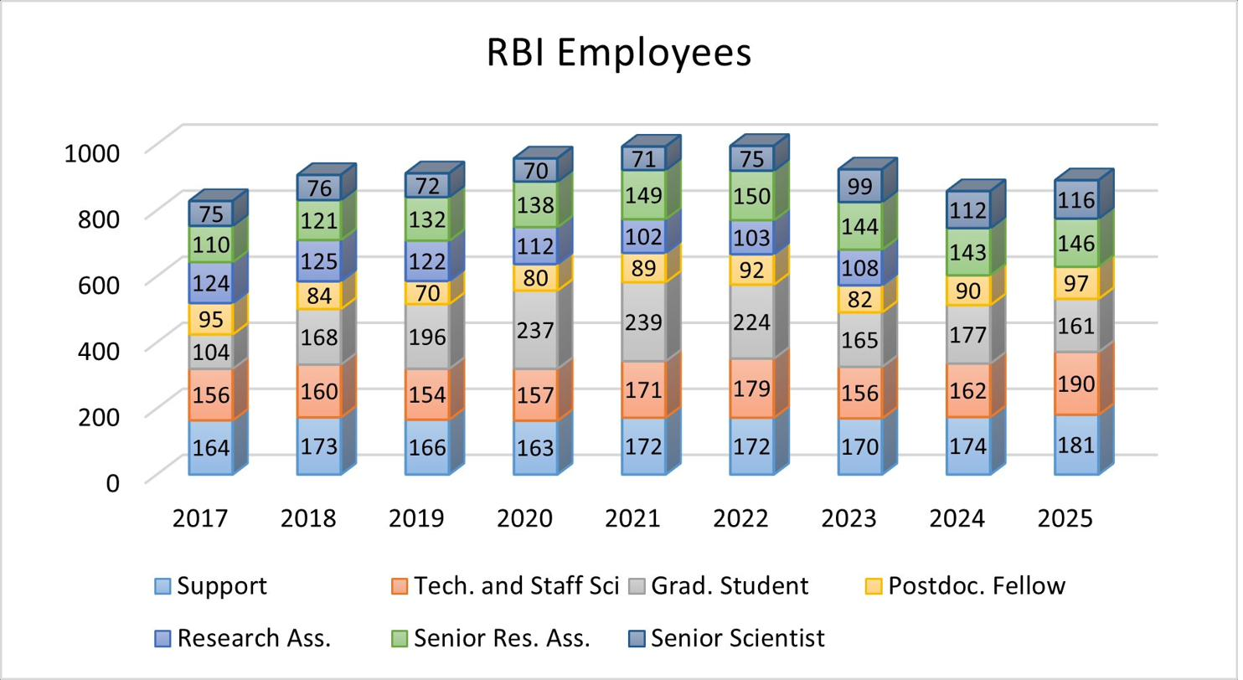
Figure 5. RBI personnel by category, 2017–2025 (headcount).
The dynamic was evident in the years preceding the current Program Agreement. A hiatus in new domestic competitive calls, associated in part with changes to the national funding framework, interrupted the flow of projects on which many early-career positions depend, and this population contracted accordingly, with the effect felt into the opening of the current period before recovering as calls resumed. Sustained international success during the same period helped offset the domestic shortfall. The episode nonetheless illustrates a genuine vulnerability the Strategy must address: the dependence of the Institute’s early-career pipeline on the rhythm of competitive funding, and the importance of building greater stability and predictability into the recruitment, development, and retention of research talent.
The same dynamic is visible in the composition of the Institute's income. Total annual income has grown substantially over the period, but the share provided by the state budget has declined as competitive and project-based funding, particularly from international sources, has grown to represent a major and increasing component of the Institute's resources. This shift has expanded the Institute's capacity and international reach, but it has also increased the Institute's exposure to the variability of competitive funding, reinforcing the importance of a stable institutional base.

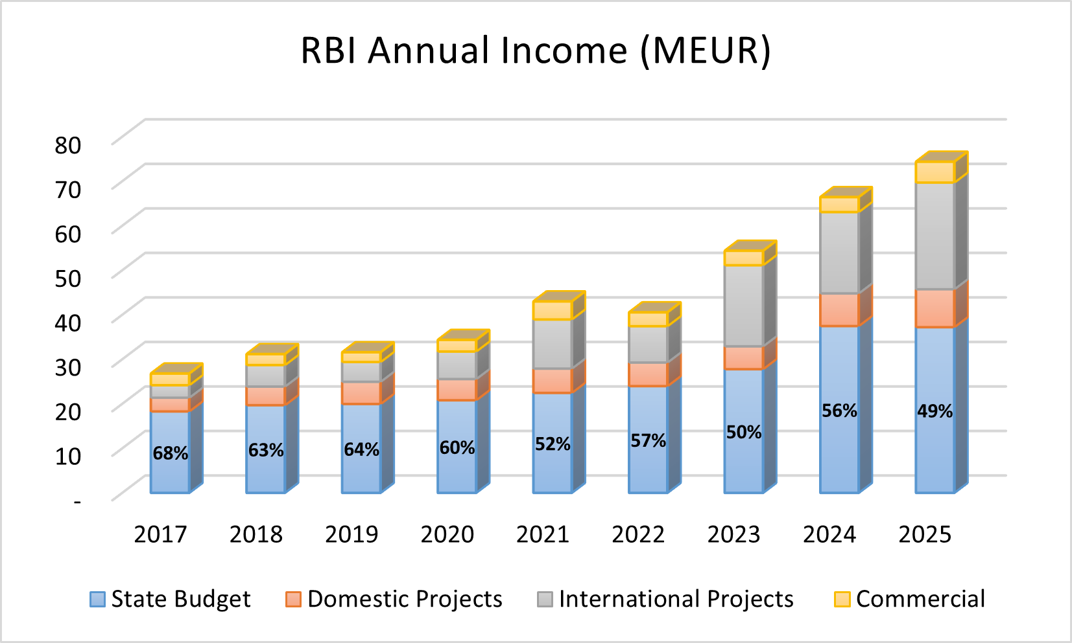
Figure 6. RBI annual income by source, 2017–2025 (M€).
A related dimension concerns the international mobility of the Institute’s researchers. The Institute actively fosters such mobility: a period of international experience is expected of those progressing to permanent research positions, a requirement that guards against insularity and keeps the Institute connected to the international research community. The corresponding challenge is therefore one of circulation rather than loss: ensuring that researchers who gain experience abroad are able to return, and that the Institute can attract back and accommodate the talent it has helped to develop. This depends in turn on the availability of suitable positions, which connects directly to the funding and establishment constraints discussed above. A distinct and largely external pressure compounds this. A broader pattern of graduate emigration, with Croatian graduates tending to leave before undertaking doctoral study, reduces the domestic pool from which the Institute draws its early-career researchers, a constraint that operates upstream of the Institute’s own recruitment and lies largely beyond its control. A smaller national pool does not simply limit the number of available candidates; it particularly complicates the recruitment of the very best, as the strongest candidates increasingly pursue careers abroad. Where the mobility the Institute fosters is a matter of circulation, this narrowing of the candidate pool is closer to genuine loss, and it bears directly on the Institute’s ability to sustain its early-career pipeline.
The Institute's role extends beyond developing its own workforce to a broader educational contribution. It is a significant contributor to doctoral education in Croatia, training and supervising a substantial number of doctoral researchers each year, and it does so in partnership with the universities that hold degree-granting authority, the Institute's educational role being exercised through these partnerships rather than independently. This partnership-based model is well established, and the relationships on which it rests offer a foundation that the Institute can build upon and deepen.
Core infrastructure has historically been the Institute’s most significant constraint. Much of the main campus dates from the 1950s, and successive strategic reviews identified the condition and capacity of physical infrastructure as a dominant weakness. The principal response is the O-ZIP project (Open Scientific Infrastructural Platforms for Innovative Applications in Economy and Society), a capital investment exceeding €100 million that represents the most substantial renewal of the Institute’s infrastructure in its modern history. O-ZIP encompasses the construction of new research buildings, the renovation of existing facilities, the modernisation of central campus systems, and, to a lesser extent, the acquisition of contemporary scientific equipment. Its completion is expected in late 2028, meaning the project will remain a significant factor in the Institute’s working environment for much of this Strategy period. In the meantime, project delivery creates certain temporary constraints. With some facilities under construction or renovation and temporarily out of use, research, technical, and administrative staff are operating under reduced spatial capacity. These constraints will remain in place until construction is complete and the new and refurbished facilities are brought into full use.
O-ZIP substantially improves the Institute’s infrastructure but does not resolve every need. The campus is large and ageing, and significant requirements will remain once the project concludes — a reality the Strategy must keep in view rather than treat as settled. Scientific equipment is a related but distinct dimension: the renewal and maintenance of major instrumentation is a continuing requirement that O-ZIP only partly addresses, though the Institute has made substantial progress in recent years in the coordinated management, maintenance, and shared use of its scientific equipment, such that this is now a more actively managed area than it once was. The project also has implications for how the Institute’s finances are read. A considerable share of the Institute’s recent income growth reflects capital funding associated with O-ZIP, which is non-recurring by nature and will conclude with the project. The Institute’s underlying recurrent funding base should therefore be understood as more modest than headline income figures alone might suggest, and financial planning for the latter part of the Strategy period must anticipate the conclusion of this exceptional capital inflow and provide for the maintenance of newly constructed facilities.
The Institute’s capacity to win and deliver complex projects rests on the full range of its professional, administrative and technical services. These span financial management, procurement, legal, human-resources, and information-technology functions; dedicated project and technology-transfer support; technical and operational services that maintain the campus and its facilities; occupational safety, radiation and fire protection, and security and logistics functions essential to a research environment of the Institute’s nature; and quality assurance and process improvement. The secretaries embedded within each scientific division form a further vital part of this fabric, providing the day-to-day interface between research activity and institutional administration. A key role is also performed by the professional and technical staff involved directly in the research process. The effectiveness of all these functions is integral to the Institute’s research performance, and many of them already operate below the capacity their responsibilities ideally require. Strengthening the Institute’s administrative and scientific organisation is further supported by active participation in international networks of institutions and the exchange of best practice, for example through initiatives such as EU-LIFE.
This creates a constraint that the Strategy must take seriously. The Institute’s ambition to expand its competitive funding is realistically bounded not only by scientific opportunity and competitive scientific infrastructure, but by the administrative capacity available to prepare, contract, and deliver projects, a burden that falls particularly, though not only, on the financial, procurement, legal, and project-support functions. That capacity is placed under growing pressure by the increasing complexity of funding rules and by the wide range of different funding instruments the Institute manages, each carrying its own regulatory, reporting, and procurement requirements. A further constraint lies largely beyond the Institute’s control: salary levels set within the national framework are not always competitive, which can make the recruitment and retention of skilled administrative, technical, and research staff more difficult. Strengthening administrative and technical capability (through investment in skilled staff, the simplification and standardisation of internal processes, and continued digitalisation, including investment in administrative infrastructure, databases, electronic systems and AI-based tools,) is therefore not a peripheral concern but a precondition for sustaining and expanding the Institute’s research activity. Meeting this need will require further strengthening of staffing capacity, including personnel responsible for quality assurance and process improvement. Building the long-term strength of these teams is closely tied to the Program Agreement framework, a point to which this analysis returns again.
The Institute's engagement with the economy takes three principal forms, and is more developed than its predominantly fundamental-research profile might suggest. The first is collaborative research and development undertaken jointly with industry partners, in which the Institute's knowledge feeds directly into the development of new products, technologies, and services; recent competitive instruments have allowed the Institute to contract a growing number of such projects. The second is the management and commercialisation of intellectual property, the protection of research results and their translation, through licensing and the formation of new companies, into commercial use. The third is the direct provision of research, analytical, and technological services to clients in both industry and the public sector, an established and steadily growing activity in which the Institute performs strongly relative to comparable institutions in the national system.
Taken together, these represent a genuine and multi-stranded capability rather than an aspiration to be built from nothing. The Institute's principal challenge in this area is one of consolidation: turning individual successes (including a number of promising technologies and an emerging, equity-based model for licensing intellectual property that has begun to demonstrate results) into systematic and routine institutional practice. The opportunity is real and growing, supported by the next programming period's pervasive emphasis on the green and digital transitions, which extends the scope for collaboration well beyond the Institute's traditional fields. As with competitive research funding more generally, however, the pace of this engagement remains tied to the rhythm and availability of the relevant funding instruments.
Communication and popularisation of science represent one of the Institute’s key functions. The communications function is professionally organised and has a demonstrated record of public engagement. The environment in which it operates, however, has become more demanding: in a contested information landscape, sustaining public understanding of and trust in science is increasingly difficult, and the reach of even effective communication cannot be taken for granted. The Institute’s position is to treat this as a serious and evolving responsibility, engaging actively and adaptively as a credible public voice for science, rather than as a settled or peripheral activity.

2.3 Summary assessment
The preceding analysis can be drawn together in a summary assessment of the Institute's position. The Institute approaches this Strategy from a foundation of scientific strength, but in an environment marked by funding volatility, infrastructure in transition, and capacity under pressure. The following summary consolidates the situation analysis into its principal dimensions.
Strengths | Weaknesses
Multidisciplinary breadth and scale  High and stable scientific output  Strengthening the quality and visibility of scientific publications  International collaboration and recognition  Proven success in major competitive and international projects  Stable core research workforce  Established science communication capability  Established provision of research and technological services to industry and the public sector | Administrative and technical capacity facing increased pressure  Ageing campus infrastructure  Recurrent funding base modest behind headline figures  Early-career pipeline sensitive to the funding cycle  Uncompetitive salaries within the national framework
Opportunities | Threats
Continued engagement with Horizon Europe and the ERA  Renewed infrastructure following O-ZIP  The 2028 Program Agreement as a strategic lever  Stronger international collaboration and partnership  Attracting researchers back through international circulation  A credible public voice for science  Growing collaborative R&D with industry and expanding green- and digital-transition funding  Scope to deepen educational partnerships with universities  Scope to leverage AI for further digitalisation and business-process optimisation  Increasing the commercialisation of research | Volatility and instability in competitive and project-based funding  Wind-down of non-recurring capital and recovery-instrument income  Growing complexity of funding rules and reporting  Transition between European funding cycles  Growing investment gap in science between Croatia and the EU  Caps on the number of project proposals per call  Emigration of graduates reducing the domestic pool of potential doctoral and postdoctoral candidates  Residual infrastructure needs beyond O-ZIP  High technology requirements for world-class scientific research

The strategic goals set out in the following section are framed as the Institute's response to this assessment, building on its established strengths while addressing the constraints and exposures that the situation analysis has identified. They translate this understanding of the Institute's position into a coherent set of priorities for the period of this Strategy.

3. Strategic goals and objectives
This section sets out the strategic goals that will guide the Institute over the period of this Strategy, together with the specific objectives through which each will be pursued. The goals are the Institute's response to the situation analysis: they build on the strengths it identified while addressing the constraints and exposures it set out.
The Institute's strategic goals are four in number. Three of them correspond to the strategic goals of the Program Agreement and carry its numbering, so that the correspondence between this Strategy and the Institute's contractual commitments remains clear: Advancing scientific excellence (SC-1), Strengthening cooperation with the economy (SC-2), and Strengthening social responsibility (SC-4). The fourth, Education and talent development (SC-3), lies outside the contractual framework and is included here as an institutional goal in its own right; it is placed in sequence among the others, with the gap in contractual numbering reflecting its distinct status.
Each goal is presented through a short statement of its rationale and the specific objectives that give it effect. Consistent with the role of this Strategy as a long-term institutional framework, the goals and objectives are expressed at the strategic level; the measurable indicators and targets through which they are monitored, and much of the detailed activity through which they are implemented, are defined through the Institute's successive Program Agreements (see: Annexes 2 and 3), whose role as the principal instrument of delivery is described in Section 4.

3.1 SC-1 — Advancing scientific excellence
Scientific excellence is the foundation of the Institute’s identity and the basis on which its other goals rest. The situation analysis confirmed both the strength of this foundation (high-quality output, an improving publication profile, and proven success in major competitive and international projects) and the conditions on which its continuation depends: a healthy flow of competitive funding, a sustainable research workforce, capable support services, and competitive infrastructure. This goal therefore encompasses not only research performance itself but the human and structural conditions that make sustained excellence possible.
The Institute will pursue this strategic goal through the following specific objectives:
- 1.1 Increasing participation in competitive project funding
- 1.3 Strengthening international scientific cooperation and activity
- 1.4 Strengthening human resources for scientific work
- 1.5 Strengthening the human resources of the professional and support services
- 1.6 Improving research infrastructure
- 1.7 Contributing to open science
- 1.8 Strengthening the interdisciplinarity of scientific work
- 1.9 Raising the international reputation of the Institute

3.2 SC-2 — Strengthening cooperation with the economy
The Institute’s scientific capabilities carry value beyond the research community, and their translation into economic and societal benefit is a strategic priority in its own right. The situation analysis showed this to be a genuine and multi-stranded area of activity, spanning collaborative research with industry and the wider society and public sector, the management and commercialisation of intellectual property, and the direct provision of research and technological services, with real strengths alongside clear room to develop. The Institute’s central ambition here is one of consolidation: building on established capability to make the commercialisation of its research a systematic part of institutional practice rather than a series of individual successes. This goal addresses that ambition, encompassing applied research undertaken in collaboration with industry and the wider society and public sector, the management of the intellectual property that arises from the Institute’s work, and the provision of scientific and technological services where these meet a real need.
The Institute will pursue this goal through the following specific objectives:
- 2.1 Promoting applied scientific activities, including projects undertaken in cooperation with industry
- 2.2 Improving the institutional management of intellectual property
- 2.3 Improving the provision of scientific, research, and technological services on the open market

3.3 SC-3 — Education and talent development
Unlike the preceding goals, this goal lies outside the contractual framework of the Program Agreement. As a public scientific institute, the Ruđer Bošković Institute does not itself award academic degrees, and education therefore does not feature among its contractual goals in the way that scientific, economic, and societal objectives do. The Institute nonetheless regards the education and development of researchers as integral to its mission, and sets it out here as an institutional goal in its own right.
The Institute's educational contribution is substantial. It trains and develops a large community of early-career researchers and contributes significantly to doctoral education in Croatia, working in partnership with universities that hold degree-granting authority. Because the development of early-career researchers, postdoctoral advancement, and international experience in the early stages of a career are already addressed through the objectives of the scientific-excellence goal, this goal is closely connected to it. The purpose of stating it separately is to give explicit strategic recognition to this dimension of the Institute's work, which its contractual goals do not fully capture, and to articulate its long-term development ambitions.
Doctoral researchers trained at a leading scientific institution have access to resources, equipment, and mentorship that can offer better prospects than at institutions with more limited research funding. The Institute seeks to recognise, build on, and further develop this advantage through the next Program Agreement, rather than leave it unaddressed.
Foremost among these is the Institute's role within its educational partnerships. The Institute's current model (developing and supervising doctoral researchers whose degrees are conferred by partner universities) can be deepened into a more substantive and formally recognised role. The legislative framework now permits a public scientific institute to co-deliver joint doctoral study programmes together with a university, opening a path for the Institute to move from contributor to co-owner of doctoral education. Pursuing such arrangements, and more broadly increasing the Institute's influence and standing within its domestic university partnerships, is an aspiration this goal seeks to advance. The same ambition extends internationally, through partnerships with foreign universities and the prospect of jointly delivered or co-supervised doctoral education that strengthens the Institute's place in the European research and education area.
The Institute will pursue this goal through the following specific objectives:
- SC-3.1 Deepening the Institute's role and influence within partnerships with domestic universities, including the pursuit of joint doctoral study programmes
- SC-3.2 Developing educational partnerships with international universities, including jointly delivered or co-supervised doctoral education
- SC-3.3 Sustaining a high-quality environment for the training, mentorship, and formative development of early-career researchers

3.4 SC-4 — Strengthening social responsibility
As a public scientific institute, the Institute contributes not only to the advancement of science and the economy but also to the realisation of broader societal benefits and the public good. The situation analysis highlighted several key aspects of this contribution: the Institute's role in matters of national significance, its established capability in the public communication of science, and the importance of conducting its own operations responsibly. This goal brings these aspects together, recognising that the Institute's standing rests not only on the quality of its scientific activity but also on the manner in which it contributes to society as a whole.
The Institute will pursue this goal through the following specific objectives:
- 4.1 Working on activities of national significance
- 4.4 Digitalisation of operations
- 4.5 Strengthening the green transition
- 4.6 Popularisation of science

4. Implementation, monitoring and review
The preceding section set out what the Institute intends to advance over the period of this Strategy; this section describes how those goals are delivered, monitored, and kept under review. As a long-term institutional framework, the Strategy is operationalised through the instruments that sit beneath it, principally the Institute’s Program Agreements with the Ministry, which define the measurable indicators, targets, and detailed activities through which the goals are pursued. The activities and Institute’s delivery against them at the mid-point of the current Program Agreement are recorded in Annexes 2 and 3.

4.1 The Program Agreement as the principal instrument of delivery
Strategic goals of the Institute are delivered principally through its successive Program Agreements with the Ministry, which translate the goals of this Strategy into specific objectives and the concrete activities through which they are pursued.
The structure of the Program Agreement follows from the national framework for programme-based financing. Each strategic goal is given effect through a set of specific objectives, and each objective in turn through defined activities, which the framework distinguishes as development activities and implementation activities according to their nature. Development activities concern the building of new capability (among them research infrastructure, the management and commercialisation of intellectual property, and organisational development), while implementation activities support the recurring work through which the Institute's objectives are met, such as the preparation of competitive project proposals, scientific publishing, the development of early-career researchers, and the public communication of science. Each activity is accompanied by measurable indicators, a defined budget, and a delivery timeline.
It is at this level (the specific objectives and their associated activities) that the operational detail of delivery resides. Consistent with the role of this Strategy as a long-term institutional framework, that detail is established in the Program Agreement. The correspondence between the strategic goals of this Strategy and the contractual objectives and activities through which they are delivered is set out in Annex 2.

4.2 Funding and the delivery framework
Delivery of development and implementation activities depends on the funding available to the Institute, which combines a stable institutional foundation with resources whose scale and timing are less predictable.
The Program Agreement provides for funding in three components. The basic component supports the Institute’s core operation (principally the salaries of staff funded from the state budget, together with the essential costs of maintaining the Institute’s activity and existing capacities) and is the stable foundation on which everything else rests. The development and implementation components fund the activities through which the specific objectives are pursued; each is set as a bounded proportion of the basic component, and within the current Agreement a substantial part of the activity they support has been delivered through competitive internal calls open to the Institute’s researchers.
A significant share of the development and implementation activity under the current Agreement has been resourced through the National Recovery and Resilience Plan, the exceptional, time-limited funding established in response to the pandemic. These instruments are not recurring, and the recovery funding that supported much of the first cycle’s activity will conclude as the plan comes to an end. This is the same non-recurring character that the situation analysis noted in relation to the Institute’s capital funding, and it bears on the development and implementation components in a comparable way: the level of activity they sustained in the first cycle reflected, in part, a source of funding that will not be available on the same terms in the next.
The programme-based financing framework itself, however, continues. It is established in national law and provides the durable structure within which the Institute's funding is negotiated across successive cycles. The question for the period of this Strategy is therefore one of transition between funding instruments within a continuing framework, rather than the loss of the framework itself — a transition the Institute approaches from the experience of a first Agreement cycle that has been successfully delivered thus far. The implications of this transition for the next Program Agreement are considered in Section 4.4.

4.3 Governance, monitoring and review
Responsibility for implementing the Strategy rests with the Institute's governance bodies, which oversee delivery and monitor progress within a framework of external accountability.
Within the Institute, the Strategy is adopted by the Management Board on the proposal of the Director and the Scientific Council. The Director leads its implementation and reports annually to the Management Board and the Scientific Council on progress against the Strategy, on the Institute's operations, and on the implementation of the Program Agreement; the Scientific Council provides scientific oversight of the Institute's work. The Institute monitors implementation of the Strategy through its internal quality assurance system, for which the Institute maintains a dedicated organisational unit and within which monitoring of the Strategy is a defined and continuing function.
The Program Agreement is monitored under the national framework for programme-based financing, through reporting by the Institute and evaluation by the Ministry in cooperation with the Agency for Science and Higher Education (ASHE). A report on implementation is prepared at the midpoint of the agreement period and again at its conclusion; the Institute has met its mid-term reporting obligation under the current agreement, and evaluation is proceeding. The results of this monitoring inform the negotiation of the subsequent Program Agreement, as set out in Section 4.4.
Separately from the Program Agreement cycle, the Institute undergoes periodic reaccreditation, coordinated by ASHE under the national quality-assurance framework. Reaccreditation assesses the Institute against established quality standards, including the operation of its internal quality assurance system, and a valid Development Strategy is among the conditions the Institute is required to maintain. While both processes involve the same agency, they serve distinct purposes: the first concerns delivery of the Institute's contractual commitments; the second, its standing as an accredited scientific institution.

4.4 The 2028 Program Agreement
A new Program Agreement covering the period 2028–2031 will be negotiated with the Ministry during the course of this Strategy, and represents the principal point at which progress is reviewed and the second half of the Strategy is set.
The negotiation draws directly on this Strategy. Under the national framework for programme-based financing, an institution's development strategy is a required basis for the negotiation, alongside its situation analysis and its projected revenues; the goals and priorities set out here are therefore the starting point from which the Institute's next agreement is shaped. The results achieved under the current agreement enter the negotiation in the same way: the goals, activities, and indicators delivered in the first cycle are taken into account in concluding the next, so that the Institute negotiates from a record of what it has accomplished.
The current Program Agreement is the first of its kind in the Croatian research system, and the Institute has delivered against it successfully thus far. The negotiation of its successor is therefore best understood not as a renewal to be defended but as an opportunity to consolidate: to carry forward what has worked, to place the development and implementation activity of the first cycle, together with the scientific and other infrastructure it supported, on a more durable footing as the recovery instruments that supported much of it conclude, and to align the Institute’s priorities with the next European programming period as it takes shape. The Institute approaches the 2028 negotiation in those terms.

4.5 Education and talent development outside the contractual framework
Because education and talent development (SC-3) lies outside the contractual goals of the Program Agreement, it is delivered and monitored through the Institute's own governance rather than through the contractual cycle described above.
In practice, the two are closely connected. Much of what this goal pursues is given effect through activities that also serve the scientific-excellence objectives (the training, mentorship, and development of early-career researchers among them) and through the Institute's partnerships with the universities that hold degree-granting authority. Progress is overseen by the Institute's governance bodies as part of their wider responsibility for the Strategy, and is monitored through the same internal quality assurance arrangements that cover the Institute's other strategic goals. In this way the Institute holds itself accountable for a goal it has chosen to set for itself, on the same footing as those it pursues under the Program Agreement.

5. Entry into force
This Development Strategy has been prepared in Croatian and English; in case of differences in interpretation, the Croatian version shall prevail.
This Development Strategy will be published on the Institute's bulletin board and website.
This Development Strategy of the Ruđer Bošković Institute 2026 – 2030 shall enter into force on the eighth day following the date of its publication.

Reference number: 010-7702/2-2026
In Zagreb, September 25, 2026

President of the Management Board

mr. sc. Marko Pavić

It is hereby established that the Ruđer Bošković Institute Development Strategy 2026 – 2030 was published on the bulletin board on September 28, 2026 and enters into force on October 6, 2026.

Director

Dr. sc. David Matthew Smith

Annex 1 — List of abbreviations
Abbreviation | Term
ASHE | Agency for Science and Higher Education
ERA | European Research Area
ESIF | European Structural and Investment Funds
IA | Implementation activity
NRRP | National Recovery and Resilience Plan
O-ZIP | Open Scientific Infrastructural Platforms for Innovative Applications in Economy and Society
RA | Development activity
RBI | Ruđer Bošković Institute
MFF | Multiannual Financial Framework

Annex 2 — Crosswalk: strategic goals to contractual objectives and activities
This annex maps the strategic goals of this Strategy to the specific objectives and activities of the Program Agreement through which they are delivered. Activities are designated as development activities (RA) or implementation activities (IA), following the structure of the national framework for programme-based financing. Goal SC-3 is an institutional goal outside the contractual framework and therefore has no associated contractual activities.
Strategic goal | Specific objective | Contractual activities
SC-1 — Advancing scientific excellence
SC-1 — Advancing scientific excellence | 1.1 Increasing participation in competitive project funding | IA-1.1.1 Project-proposal development (national)  IA-1.1.2 Support for publishing in prestigious journals  IA-1.1.3 Scientific journals
 | 1.3 Strengthening international scientific cooperation and activity | IA-1.3.1 Project-proposal development (international)  IA-1.3.2 Researcher mobility  RA-1.3.1 Support for returning researchers  RA-1.3.2 Organisation of international conferences  RA-1.3.3 Membership in international organisations
 | 1.4 Strengthening human resources for scientific work | IA-1.4.1 Support for postdoctoral advancement  IA-1.4.2 Training for early-career researchers  RA-1.4.1 Funding the development of young scientists
 | 1.5 Strengthening the human resources of the professional and support services | RA-1.5.1 Strengthening professional-service capacity  RA-1.5.2 Training for professional-service capacity
 | 1.6 Improving research infrastructure | RA-1.6.1 Acquisition of new and upgrading of existing scientific equipment  RA-1.6.2 Construction, reconstruction, adaptation and equipping of facilities
 | 1.7 Contributing to open science | IA-1.7.1 Promoting open science
 | 1.8 Strengthening the interdisciplinarity of scientific work | IA-1.8.1 Project-proposal development (interdisciplinary)
 | 1.9 Raising the international reputation of the Institute | IA-I.9.1 Incentive projects for the best scientific work  IA-I.9.2 Division incentive projects
SC-2 — Strengthening cooperation with the economy
SC-2 — Strengthening cooperation with the economy | 2.1 Promoting applied scientific activities, including projects undertaken in cooperation with industry | RA-2.1.1 Applied-research projects
 | 2.2 Improving the institutional management of intellectual property | RA-2.2.1 Knowledge-transfer activities
 | 2.3 Improving the provision of scientific, research, and technological services on the open market | RA-2.3.1 Specialist and technical staff for managing capital equipment and laboratory facilities  RA-2.3.2 Maintenance of capital equipment
SC-3 — Education and talent development
SC-3 — Education and talent development | Institutional goal (non-contractual) | No separate contractual activities  pursued through the SC-1 objectives above and through the Institute’s partnerships with universities
SC-4 — Strengthening social responsibility
SC-4 — Strengthening social responsibility | 4.1 Working on activities of national significance | RA-4.1.1 Projects of public interest  RA-4.1.2 Support for the development and maintenance of the CroRIS system
 | 4.4 Digitalisation of operations | RA-4.4.1 Introduction of new digital forms of operation
 | 4.5 Strengthening the green transition | RA-4.5.1 Raising energy efficiency
 | 4.6 Popularisation of science | IA-4.6.1 Popularisation of science

Annex 3 — Mid-point delivery against the Program Agreement indicators
This annex reports the Institute's position at the mid-point of the current Program Agreement (2024–2027), comparing the value achieved at the mid-point key-achievement point against the value contracted for that point. In line with the indicator definitions of the Program Agreement, each value is calculated over the four years to the mid-point (2021–2024), as reported in the Institute's mid-term report. The figures record where the Institute stands, not what it undertakes to achieve; the contractual indicators, their targets, and the activities through which they are pursued are established in the Program Agreement, as described in Section 4 and mapped in Annex 2. At the mid-point, the Institute met or exceeded every contracted indicator value. Four sub-indicators, shown with a dash (—) in the target column, were reported without a contracted target; their achieved values are included for completeness.

SC-1 — Advancing scientific excellence
Indicator | Mid-point target | Achieved
1.1 Increasing participation in competitive project funding
PR-1.1.1 Successful applications to competitive funding sources | 120 | 143
of which: ERC and other international programmes | — | 55
PR-1.1.2 Value of competitive research projects (€) | 28,500,000 | 35,476,831
of which: ERC and other international programmes (€) | — | 14,985,035
PR-1.1.3 Papers in SCOPUS and WoS / A1 journals | 3,200 | 3,234
1.3 Strengthening international scientific cooperation and activity
PR-1.3.1 Successful applications with a foreign partner | 60 | 103
PR-1.3.2 Collaborations with foreign partners | 1,050 | 1,673
PR-1.3.3 Researchers engaged in mobility activities | 60 | 60
1.4 Strengthening human resources for scientific work
PR-1.4.1 Researchers gaining a qualification or completing postdoctoral training externally | 250 | 295
PR-1.4.2 Completed doctorates | 125 | 175
of which: doctorates of international doctoral students | — | 9
PR-1.4.3 Researchers employed from earmarked / own funds | 175 | 188
1.5 Strengthening the human resources of the professional and support services
PR-1.5.1 Training sessions attended and delivered | 165 | 195
PR-1.5.2 Activities to strengthen support-service competencies | 45 | 55
PR-1.5.3 Project applications delivered with support-service involvement | 120 | 415
1.6 Improving research infrastructure
PR-1.6.1 Investment in research equipment from own funds (€) | 750,000 | 1,152,458
PR-1.6.2 Investment in research infrastructure from own funds (€) | 25,000 | 990,883
1.7 Contributing to open science
PR-1.7.1 Measures and tools introduced to promote open science | 55 | 232
1.8 Strengthening the interdisciplinarity of scientific work
PR-1.8.1 Successful interdisciplinary project applications | 110 | 111
I.9 Raising the international reputation of the Institute (institutional indicator)
PR-I.9.1 Papers in WoS Q1 (top 25%) | 1,400 | 1,710
PR-I.9.2 Papers in WoS D1 (top 10%) | 400 | 429
PR-I.9.3 Papers in the Nature Index | 430 | 472

SC-2 — Strengthening cooperation with the economy
Indicator | Mid-point target | Achieved
2.1 Promoting applied scientific activities, including projects undertaken in cooperation with industry
PR-2.1.1 Successful applications for applied-research projects | 15 | 24
of which: collaborative applications with industry, culture or education | — | 15
PR-2.1.2 Formal collaborations with economic, cultural and educational entities | 45 | 53
2.2 Improving the institutional management of intellectual property
PR-2.2.1 Patent applications | 6 | 10
PR-2.2.2 Other forms of intellectual property | 1 | 1
PR-2.2.3 Technology- and knowledge-transfer projects initiated | 4 | 4
2.3 Improving the provision of scientific, research, and technological services on the open market
PR-2.3.1 Contracted service projects for industry and public bodies | 1,700 | 2,084
PR-2.3.2 Value of service projects for industry and public bodies (€) | 11,500,000 | 13,769,947

SC-4 — Strengthening social responsibility
Indicator | Mid-point target | Achieved
4.1 Working on activities of national significance
PR-4.1.1 Formalised collaborations with state and public-sector bodies | 60 | 73
4.4 Digitalisation of operations
PR-4.4.1 Own / earmarked funds spent on digital-transformation projects (€) | 45,000 | 88,400
4.5 Strengthening the green transition
PR-4.5.1 Own / earmarked funds spent on energy-efficiency projects (€) | 2,250,000 | 3,459,464
4.6 Popularisation of science
PR-4.6.1 Science- and art-popularisation activities | 450 | 452

